

**Green University of Bangladesh**

**Department of Computer Science and Engineering (CSE)**

**Semester: (Spring, Year:2024), B.Sc. in CSE (Day)**

**Lab Report NO #06**

**Course Title: Database System Lab**

**Course Code: CSE 210 Section: 221 D1**

**Lab Experiment Name:** Implementation of Database Triggers.

**Student Details**

| **Name** | | **ID** |
| --- | --- | --- |
| **1.** | Tanvir Ahmed | 221002461 |

**Lab Date : 20/5/2024**

**Submission Date : 27/5/2024**

**Course Teacher’s Name : Dr. Faiz Al Faisal**

| **Lab Report Status**  **Marks: ………………………………… Signature:.....................**  **Comments:.............................................. Date:..............................** |
| --- |

**1. TITLE OF THE LAB REPORT EXPERIMENT**

Implementation of Database Triggers.

**2. OBJECTIVES/AIM**

* To create a database
* To create tables in the database based on the problem
* To insert data into each table based on the problem.
* To Implement the Lab Task and Lab Exercise using the Triggers.
* Show the outputs of change.

**3. PROCEDURE**

* At first, we created a database named lab9.
* Then create some tables based on the lab exercise problem.
* Now insert data on each table.
* Implement lab tasks and lab exercises using triggers.
* Show the final outputs.

**4. IMPLEMENTATION**

**1:**

Source Code:

USE lab9;

CREATE TABLE employee (

EmpID INT PRIMARY KEY,

EmpName VARCHAR(50),

BasicSalary DOUBLE,

StartDate DATE,

NoofPub INT

);

INSERT INTO employee VALUES

(1, 'John Doe', 50000, '2023-01-01', 5),

(2, 'Jane Smith', 60000, '2022-05-15', 3),

(3, 'Michael Johnson', 55000, '2022-12-10', 2),

(4, 'Emily Brown', 52000, '2023-06-20', 1),

(5, 'David Lee', 48000, '2023-03-08', 6),

(6, 'Sarah Clark', 53000, '2023-09-30', 0),

(7, 'Daniel Wang', 57000, '2022-08-05', 4),

(8, 'Olivia Martinez', 59000, '2022-04-18', 2),

(9, 'James Taylor', 51000, '2023-02-14', 3),

(10, 'Emma White', 54000, '2023-11-25', 5);

SELECT * FROM employee;

DELIMITER //

CREATE TRIGGER update_salary_trigger BEFORE UPDATE ON employee

FOR EACH ROW

BEGIN

DECLARE job_duration INT;

SET job_duration = DATEDIFF(CURRENT_DATE(), NEW.StartDate);

IF job_duration > 365 THEN

IF NEW.NoofPub > 4 THEN

SET NEW.BasicSalary = NEW.BasicSalary * 1.20;

ELSEIF NEW.NoofPub = 2 OR NEW.NoofPub = 3 THEN

SET NEW.BasicSalary = NEW.BasicSalary * 1.10;

ELSEIF NEW.NoofPub = 1 THEN

SET NEW.BasicSalary = NEW.BasicSalary * 1.05;

ELSE

SET NEW.BasicSalary = NEW.BasicSalary;

END IF;

END IF;

END;

//

DELIMITER ;

-- dummy update

UPDATE employee SET EmpID = EmpID;

SELECT * FROM employee;

**2:**

USE lab9;

CREATE TABLE StudentInfo (

StudentID INT PRIMARY KEY,

StudentName VARCHAR(100),

Address VARCHAR(255),

Email VARCHAR(100)

);

CREATE TABLE WaiverInfo (

StudentID INT PRIMARY KEY,

StudentName VARCHAR(100),

CGPA FLOAT,

WaiverPercentage INT,

FOREIGN KEY (StudentID) REFERENCES StudentInfo(StudentID)

);

INSERT INTO StudentInfo (StudentID, StudentName, Address, Email) VALUES

(1, 'Tanvir Ahmed', 'Sylhet', 'tanvir@example.com'),

(2, 'Ahmed Tanvir', 'Habiganj', 'ahmed@example.com'),

(3, 'Example', 'Dhaka', 'example@example.com'),

(4, 'Example Example', 'Barishal', 'example2@example.com'),

(5, 'Jhon Cina', 'America', 'Jhon@example.com');

INSERT INTO WaiverInfo (StudentID, StudentName, CGPA, WaiverPercentage) VALUES

(1, 'Tanvir Ahmed', 3.6, 0),

(2, 'Ahmed Tanvir', 3.3, 0),

(3, 'Example', 3.1, 0),

(4, 'Example Example', 2.8, 0),

(5, 'Jhon Cina', 2.7, 0);

SELECT * FROM WaiverInfo;

DELIMITER //

CREATE TRIGGER update_waiver BEFORE UPDATE ON WaiverInfo

FOR EACH ROW

BEGIN

IF NEW.CGPA >= 3.5 THEN

SET NEW.WaiverPercentage = 100;

ELSEIF NEW.CGPA >= 3.25 THEN

SET NEW.WaiverPercentage = 60;

ELSEIF NEW.CGPA >= 3.00 THEN

SET NEW.WaiverPercentage = 40;

ELSEIF NEW.CGPA >= 2.75 THEN

SET NEW.WaiverPercentage = 30;

ELSE

SET NEW.WaiverPercentage = 0;

END IF;

END;

//

DELIMITER ;

-- dummy update

UPDATE WaiverInfo SET StudentID = StudentID;

SELECT * FROM WaiverInfo

**5. TEST RESULT / OUTPUT**

**1:**

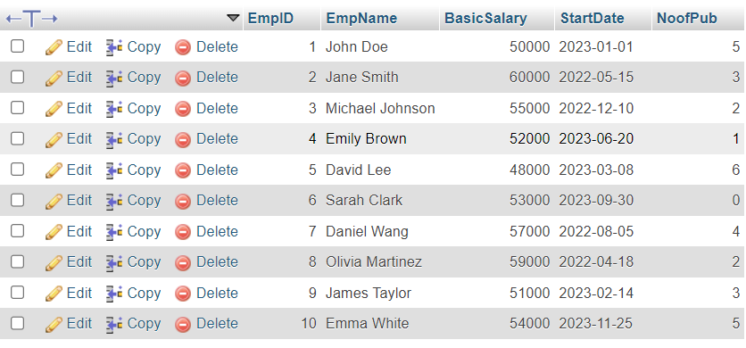

fig1.Before Trigger.

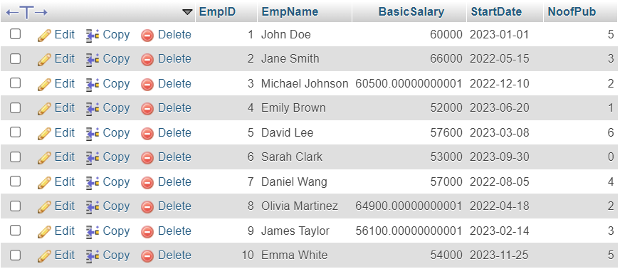

fig2. After Trigger.

**2:**

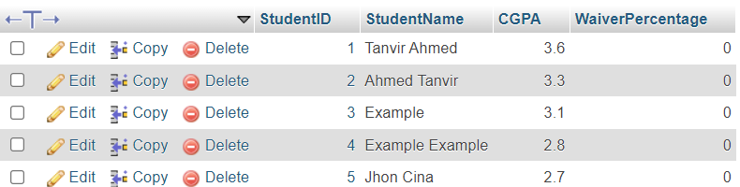

fig1.Before Trigger.

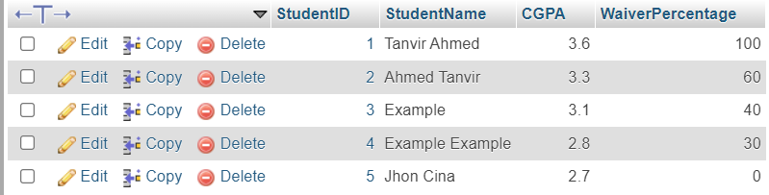

fig2. After Trigger.

**6. ANALYSIS AND DISCUSSION**

* In this exercise, the database called ‘lab9’ was first successfully created.
* Then we created some tables based on the lab exercise given in the lab manual.
* We insert information into each table using INSERT INTO statements.
* I solve the problems using the triggers and dummy updates.
* Screenshots showing all the outputs based on the exercise.

**7. SUMMARY**

This lab exercise demonstrates practical applications of SQL Database Triggers that I learned from the previous class. I implemented the lab task and exercise by creating a database, and tables, inserting data into each table from the lab manual, and showing outputs based on the exercise needs. The output comes perfectly.